**With PARTsolutions the time for parts creation and search reduces by 80%**Toyo Seikan drastically reduces the workload for its designers

**Augsburg, Germany, 12th October 2016.** Toyo Seikan has been producing PET bottles, cans, plastic and metal packaging containers since 1917. The Strategic Parts Management PARTsolutions from CADENAS has been supporting the Japanese manufacturer since 2008 as a supplier parts library for the design of production equipment. Due to the use of numerous supplier parts in Toyo Seikan products, an important factor for their 3D designing was to rapidly obtain accurate 3D CAD data. Another additionally important issue was reducing the man-hour design costs. The “easy to integrate in existing systems” ability has been a key factor in Toyo Seikan‘s choice for CADENAS.

**Search and creation of supplier parts is reduced by 80%**

Thanks to Stratgic Parts Management PARTsolutions, designers at Toyo Seikan only need a few seconds to find components and to download them into into their CAD system. Furthermore, the obtained catalog data already contains manufacturers’ original attributes, to which Toyo Seikan can add its self-managed information and metadata: Within the PARTsolutions parts library, it is possible to assign values such as part numbers and inventory information. In the case of commonly used standard parts Toyo Seikan can assign its own catalog references and simplify the search effort greatly due to the ease of use. Also through the library management multiple re-creations of the same parts are avoided.

With the introduction of the Strategic Parts Management PARTsolutions Toyo Seikan reduced time and costs drastically: "Compared to conventional approaches, the entire process has been reduced to one-fifth of the time, which greatly reduces the workload of designers“, confirmed Mr. Nagata, Assistant Manager of Toyo Seikan

For further information about the use of PARTsolutions at Toyo Seikan see the [common success story](https://www.cadenas.de/tl_files/cadenas/Downloads/PDF/Referenzen/EN/PARTsolutions_TOYO_Success_Story_EN.pdf).

If you want to know more about the Strategic Parts Management PARTsolutions CADENAS, we recommend our [digital brochure](https://www.cadenas.de/tl_files/cadenas/Downloads/PDF/Produktflyer/EN/CADENAS_PARTsolutions_Brochure_EN.pdf). We are also happy to send you a printed copy, requests can be sent via email: [Marketing@cadenas.de](mailto:Marketing@cadenas.de) or by phone at +49 (0) 821 258 58 0-0.

**Press Images:**

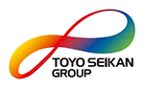

**Caption 1:** Toyo Seikan has been producing PET bottles, cans, plastic and metal packaging containers since 1917. The Strategic Parts Management PARTsolutions from CADENAS has been supporting the Japanese manufacturer.

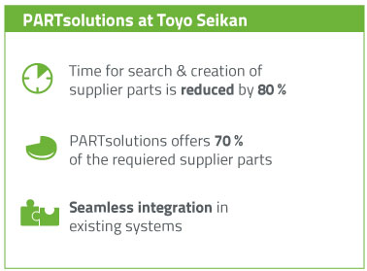

**Caption 2:** Overview about the Strategic Parts Management PARTsolutions at Toyo Seikan.

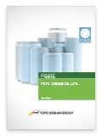

**Caption 3:** The common success story of Toyo Seikan and CADENAS describes the introduction of the Strategic Parts Management PARTsolutions and others.

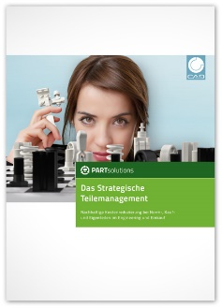**Caption 4:** Further more Information about the Strategic Parts Management PARTsolutions in the digital or printed brochure.

This press release and accompanying images are available for download from our website: [www.cadenas.de/press/press-releases](http://www.cadenas.de/press/press-releases)

**About CADENAS**

CADENAS is a leading software developer in the areas of Strategic Parts Management and parts reduction (PARTsolutions), as well as Electronic Product Catalogs (eCATALOGsolutions). With its customized software solutions, the company acts as a link between the component manufacturers with their products and the purchasers.

With its 300 employees at 17 international subsidiaries, the name CADENAS (Hispanic: process chains) has been standing for success, creativity, support and process optimization since 1992.

For further information, please visit: www.cadenas.de/en